**ASSIGNMENT 1 FRONT SHEET**

|  |  |  |  |
| --- | --- | --- | --- |
| **Qualification** | **BTEC Level 5 HND Diploma in Computing** | | |
| **Unit number and title** | Unit 2: Networking Infrastructure | | |
| **Submission date** | 14/12/2021 | **Date Received 1st submission** |  |
| **Re-submission Date** |  | **Date Received 2nd submission** |  |
| **Student Name** | Truong Van Tuan Kiet | **Student ID** | GCC2000203 |
| **Class** | GCC0903 | **Assessor name** | Le Huynh Quoc Bao |
| **Student declaration**  I certify that the assignment submission is entirely my own work and I fully understand the consequences of plagiarism. I understand that making a false declaration is a form of malpractice. | | | |
|  |  | **Student’s signature** |  |

**Grading grid**

|  |  |  |  |  |  |  |
| --- | --- | --- | --- | --- | --- | --- |
| P1 | P2 | P3 | P4 | M1 | M2 | D1 |
|  |  |  |  |  |  |  |

|  |  |  |
| --- | --- | --- |
| **❒ Summative Feedback: ❒ Resubmission Feedback:** | | |
| **Grade:** | **Assessor Signature:** | **Date:** |
| **Lecturer Signature:** | | |

# Assignment Brief 1 (RQF)

## Higher National Certificate/Diploma in Computing

|  |  |
| --- | --- |
| **Student Name/ID Number:** |  |
| **Unit Number and Title:** | **Unit 2: Networking** |
| **Academic Year:** | **2021 – 2022** |
| **Unit Assessor:** | **Van Ho** |
| **Assignment Title:** | **Networking Infrastructure** |
| **Issue Date:** | **April 1st, 2021** |
| **Submission Date:** |  |
| **Internal Verifier Name:** |  |
| **Date:** |  |

|  |
| --- |
| **Submission Format:** |
| *Format:*   * The submission is in the form of an individual written report. This should be written in a concise, formal business style using single spacing and font size 12. You are required to make use of headings, paragraphs and subsections as appropriate, and all work must be supported with research and referenced using the Harvard referencing system. Please also provide a bibliography using the Harvard referencing system.   *Submission*   * Students are compulsory to submit the assignment in due date and in a way requested by the Tutor. * The form of submission will be a soft copy posted on <http://cms.greenwich.edu.vn/>. * Remember to convert the word file into PDF file before the submission on CMS.   *Note:*   * The individual Assignment *must* be your own work, and not copied by or from another student. * If you use ideas, quotes or data (such as diagrams) from books, journals or other sources, you must reference your sources, using the Harvard style. * Make sure that you understand and follow the guidelines to avoid plagiarism. Failure to comply this requirement will result in a failed assignment. |
| **Unit Learning Outcomes:** |
| **LO1** Examine networking principles and their protocols.  **LO2** Explain networking devices and operations. |
| **Assignment Brief and Guidance:** |
| **Assignment scenario**  You are employed as a network engineer by Nguyen Networking Limited, a high-tech networking solution development company, which has branches in Ho Chi Minh City, Hanoi, Da Nang and Can Tho. The company has been contracted to implement a networking project from a local educational institute. The specification of the project is given below:   * People: 200 students, 15 teachers, 12 marketing and administration staff, 5 higher managers including the academic heads and the programme managers, and 3 computer network administrators. * Resources: 50 student lab computers, 35 staff computers, and 3 printers. * Building: 3 floors, all computers and printers are on the ground floor apart from the IT labs – one lab located on the first floor and another located on the second floor.   **Task 1**  The CEO of the company, Mr. Nguyen, has asked you to investigate and explain networking principles, protocols and devices and submit a report.  You will need to produce a report that includes the following:   * An introduction to provide an overview of your report. * Benefits and constraints of different types of networks and networking standards. * The impact of network topology, speed of communication and bandwidth requirements. * Effectiveness of networking systems. * Discussion on operating principles of networking devices and server types and networking software. * Discuss the relationship of workstation hardware with networking software. * Explore a range of server types and justify the selection of a server, considering a given scenario regarding cost and performance optimization. * For the given specification, identify the topology protocol for the efficient utilization of a networking system. |

|  |  |  |  |
| --- | --- | --- | --- |
| **Learning Outcomes and Assessment Criteria (Assignment 1):** | | | |
| Learning Outcome | Pass | Merit | Distinction |
| **LO1** | **P1** Discuss the benefits and constraints of different network types and standards.  **P2** Explain the impact of network topology, communication and bandwidth requirements. | **M1** Compare common networking principles and how protocols enable the effectiveness of networked systems. | **D1** Considering a given scenario, identify the topology protocol selected for the efficient utilization of a networking system. |
| **LO2** | **P3** Discuss the operating principles of networking devices and server types.  **P4** Discuss the inter-dependence of workstation hardware with relevant networking software. | **M2** Explore a range of server types and justify the selection of a server, considering a given scenario regarding cost and performance optimisation. |

**Table of Content**

Assignment Brief 1 (RQF) 2

Higher National Certificate/Diploma in Computing 2

I. Discuss the benefits and constraints of different network types and standards. 7

1. What is a network. 7

2. Types of Networks in use today: 7

a. Personal Area Network (PAN) 7

b. Local Area Network (LAN) 7

c. Wireless Local Area Network (WLAN) 8

d. Campus Area Network (CAN) 9

e. Metropolitan Area Network (MAN) 9

f. Wide Area Network (WAN) 10

g. Storage-Area Network (SAN) 10

h. Passive Optical Local Area Network (POLAN) 11

i. Enterprise Private Network (EPN) 11

j. Virtual Private Network (VPN) 12

3. Protocols 12

4. Standards 13

II. Explain the impact of network topology, communication and bandwidth requirements 15

1. Define topology 15

**2.** **Type of Topology:** 15

3. Define network communication: 22

4. Network rules. 23

a. Rules in the network 23

b. Why network rules are needed? 24

5. Bandwidth. 24

a. Define bandwidth. 24

b. Why bandwidth requirement is needed for networks? 24

III. Discuss the operating principles of networking devices and server types. 25

1. Discuss how switches and routers operate in a network. 25

a. How switch operate in a network. 25

b. How router operate in a network. 25

2. List some other common networking devices specify their uses, and under what circumstances. 26

a. Network Interface Card (NIC) 26

b. Hub 27

c. Operation of Hub 28

d. Ethernet Card 28

e. Bridge 29

f. Gateway 29

3. Some common types of servers 30

a. Web server 30

b. Proxy server 31

c. Virtual machine (VM) 31

d. File transfer protocol (FTP) server 31

e. Application server 31

f. File server 31

g. Database server 31

h. Print server 31

i. Domain name system (DNS) server 32

j. Collaboration server 32

k. Gaming server 32

l. Monitoring and management server 32

IV. Discuss the inter-dependence of workstation hardware with relevant networking software. 32

1. Definition of workstation hardware: 32

2. Definition of networking software: 33

3. Definition of inter-dependencies: 33

4. The inter-dependence of workstation hardware with relevant networking software: 33

References 34

**Assignment 1**

1. **Discuss the benefits and constraints of different network types and standards.**
2. **What is a network.**

A network consists of two or more computers that are linked in order to share resources (such as printers and CDs), exchange files, or allow electronic communications. The computers on a network may be linked through cables, telephone lines, radio waves, satellites, or infrared light beams.

(College of Education, University of South Florida, 1997-2013)

1. **Types of Networks in use today:**
2. **Personal Area Network (PAN)**

**Introduction:**

The smallest and most basic type of network, a PAN is made up of a wireless modem, a computer or two, phones, printers, tablets, etc., and revolves around one person in one building. These types of networks are typically found in small offices or residences, and are managed by one person or organization from a single device.

(Stéphane Bourgeois, 2016)

**Advantage:**

Easy to use in the office, conference, and meetings.

Data is easy to sync between different devices.

Connect to many devices at a time.

**Disadvantage:**

PAN can't use at an immense range.

Slow data transfer

Interfere with radio signals.

### b. Local Area Network (LAN)

**Introduction:**

LANs are the most frequently discussed networks, one of the most common, one of the most original and one of the simplest types of networks. LANs connect groups of computers and low-voltage devices together across short distances (within a building or between a group of two or three buildings in close proximity to each other) to share information and resources. Enterprises typically manage and maintain LANs.

(Stéphane Bourgeois, 2016)

**Advantage:**

Easy sharing of resources such as hard disk drives, DVD drives, and Printers.

Easy to exchange messages and data between users.

Centralized Data, data of the users are located at the centralized server. Any workstation in the network can be used this data.

Improved Security, data is stored on a local server, it can be guaranteed to be secure.

**Disadvantage:**

The initial cost is quite high because purchasing hardware equipment such as routers, hubs, switches, and cables is required for the first-time setup.

LAN often faces hardware problems and system failure.

Area coverage is limited.

Server crashes all the connected computers are affected too.

1. **Wireless Local Area Network (WLAN)**

**Introduction:**

Functioning like a LAN, WLANs make use of wireless network technology, such as Wi-Fi. Typically seen in the same types of applications as LANs, these types of networks don’t require that devices rely on physical cables to connect to the network.

(Stéphane Bourgeois, 2016)

**Advantage:**

Wireless LANs are completely free of cables and jacks, so cheap cost.

Easy to add or remove a new workstation in WLAN.

Easy to connect to WLAN while free moving within the coverage range.

Does not have physical wires. Easy to add or remove a new workstation in WLAN.

Easy to connect to WLAN while free moving within the coverage range.

Does not have physical wires.

**Disadvantage:**

WLANs are difficult to set up to run stability.

The transmission speed of WLAN is slower compared to a wired network because it uses radio frequency waves.

Unauthorized users can easily hack the data that is being transferred in WLAN.

Area Coverage, when users move away from area coverage, the signal deteriorates.

### d. Campus Area Network (CAN)

**Introduction:**

Larger than LANs, but smaller than metropolitan area networks (MANs, explained below), these types of networks are typically seen in universities, large K-12 school districts or small businesses. They can be spread across several buildings that are fairly close to each other so users can share resources.

(Stéphane Bourgeois, 2016)

**Advantage:**

The CAN (Campus area network) is very cost-effective because only a limited no of switches routers are used in the campus area.

Uses Wireless connections.

Using only one Internet Service Provider, help the CAN easy to maintenance and repair.

The fact that transmits and receive data in the campus area network is easy and reliable.

**Disadvantage:**

Limited connections, The CANs are only used for a limited area, we cannot use them for the large area networks.

Maintenance and repair of CANs are expensive as compared to other networks.

### e. Metropolitan Area Network (MAN)

**Introduction:**

These types of networks are larger than LANs but smaller than WANs – and incorporate elements from both types of networks. MANs span an entire geographic area (typically a town or city, but sometimes a campus). Ownership and maintenance is handled by either a single person or company (a local council, a large company, etc.).

(Stéphane Bourgeois, 2016)

**Advantage**:

Sending local emails, users can send local emails on MAN fast and free.

High speed, MAN uses fiber optics the speed of data can easily reach 1000 Mbps.

MAN can connect two LANs together

**Disadvantage:**

Difficult To Manage, If the network has a lot of number LANs network and big size.

MAN can connect two or many LANs together, so a high cost is needed for fiber optics.

### f. Wide Area Network (WAN)

**Introduction:**

Slightly more complex than a LAN, a WAN connects computers together across longer physical distances. This allows computers and low-voltage devices to be remotely connected to each other over one large network to communicate even when they’re miles apart.

The Internet is the most basic example of a WAN, connecting all computers together around the world. Because of a WAN’s vast reach, it is typically owned and maintained by multiple administrators or the public.

(Stéphane Bourgeois, 2016)

**Advantage:**

Area Coverage, WAN generally covers geographical areas of large proportions (1000kms or more than that).

Updated Files, Companies can work to update files from the servers so that all user devices can connect and receive them.

Message Exchange, Easy and fast communication through messages with the help of applications such as Messenger and WhatsApp.

**Disadvantage:**

Security, Since WAN has more technologies combined with each other, it faces more security issues compared to LAN and MAN.

Disconnection Problems, in remote locations no proper electricity supply or line structure, users are often disconnected.

Maintenance Issues, Maintaining WAN is a difficult task because WAN needs to maintain the data center to operate 24/7.

### g. Storage-Area Network (SAN)

**Introduction:**

As a dedicated high-speed network that connects shared pools of storage devices to several servers, these types of networks don’t rely on a LAN or WAN. Instead, they move storage resources away from the network and place them into their own high-performance network. SANs can be accessed in the same fashion as a drive attached to a server. Types of storage-area networks include converged, virtual and unified SANs.

(Stéphane Bourgeois, 2016)

**Advantage:**

Speed, SAN uses fiber optics technology, it's possible to achieve a speed of over 5Gbps.

Security, the algorithms of SAN are written in a way to protect every piece of data stored in it, so very little chance of data being stolen from SAN.

Reliability, when the server or a switch fails, the traffic will be rerouted to avoid failures. After that sever start again the operations will be continued.

Data Backup, users easily back up data on sever with less time and use this data everywhere.

**Disadvantage:**

Cost, purchasing, and maintaining a SAN require a significant amount of cost.

Privacy, although the algorithms of SAN are written in a way to protect every piece of data stored in it, still there is a possibility of data leakage.

Complexity, as SANs use sophisticated storage devices. It needs maintenance and support from IT professionals.

### h. Passive Optical Local Area Network (POLAN)

**Introduction**

As an alternative to traditional switch-based Ethernet LANs, POLAN technology can be integrated into structured cabling to overcome concerns about supporting traditional Ethernet protocols and network applications such as PoE (Power over Ethernet). A point-to-multipoint LAN architecture, POLAN uses optical splitters to split an optical signal from one strand of single mode optical fiber into multiple signals to serve users and devices.

(Stéphane Bourgeois, 2016)

**Advantage**

High speed, because POLAN uses fiber optics so data can transfer with the speed of light.

Security, because POLAN uses fiber optics so it is difficult to be attacked.

Supports telephone: POLAN supports telephone, TV access, video conference, gaming consoles with one connection.

**Disadvantage**

High cost, some components of POLAN like emitters, fiber optics cables, patch codes, and adapters are very expensive.

Installation issues: POLAN needed a skillful person to set up.

Difficult to detect a failure in the network.

### i. Enterprise Private Network (EPN)

**Introduction:**

These types of networks are built and owned by businesses that want to securely connect its various locations to share computer resources.

(Stéphane Bourgeois, 2016)

**Advantage:**

Security, EPNs are higher security than other public networks.

Easy to store and retrieve data because it is using cloud storage.

The EPN can scale up quickly without a lot of expense.

**Disadvantage:**

High cost, EPN uses fiber optics so very expensive.

Difficult connect different branches of the company.

### j. Virtual Private Network (VPN)

**Introduction:**

By extending a private network across the Internet, a VPN lets its users send and receive data as if their devices were connected to the private network – even if they’re not. Through a virtual point-to-point connection, users can access a private network remotely.

(Stéphane Bourgeois, 2016)

**Advantage:**

Bypass Geo-Restrictions, VPN will hide user's real IP address, so users access various platforms without restrictions.

Increased Online Privacy, with a VPN, the user's real IP address is hidden. Other people can't monitor and track user data.

Free from Online Censorship, some countries ban online services and websites from foreign, with VPN users can access online services and websites these countries.

**Disadvantage:**

Illegal, some countries are working to ban the use of VPNs.

Decreased Performance, VPN will connect your network to a private server, so you will take longer to load.

Monitoring by the Service, some VPNs monitor, and track user data online activity.

Increased Cost, a good VPN requires payment which can be up to $100 every year.

1. **Protocols**

**Introduction:**

In networking, a protocol is a set of rules for formatting and processing data. Network protocols are like a common language for computers. The computers within a network may use vastly different software and hardware; however, the use of protocols enables them to communicate with each other regardless.

**Purpose:**

Standardized protocols are like a common language that computers can use, similar to how two people from different parts of the world may not understand each other's native languages, but they can communicate using a shared third language. If one computer uses the Internet Protocol (IP) and a second computer does as well, they will be able to communicate — just as the United Nations relies on its 6 official languages to communicate amongst representatives from all over the globe. But if one computer uses IP and the other does not know this protocol, they will be unable to communicate.

**Some of the most important protocols to know are:**

-TCP: As described above, TCP is a transport layer protocol that ensures reliable data delivery. TCP is meant to be used with IP, and the two protocols are often referenced together as TCP/IP.

-HTTP: The Hypertext Transfer Protocol (HTTP) is the foundation of the World Wide Web, the Internet that most users interact with. It is used for transferring data between devices. HTTP belongs to the application layer (layer 7), because it puts data into a format that applications (e.g. a browser) can use directly, without further interpretation. The lower layers of the OSI model are handled by a computer's operating system, not applications.

-HTTPS: The problem with HTTP is that it is not encrypted — any attacker who intercepts an HTTP message can read it. HTTPS (HTTP Secure) corrects this by encrypting HTTP messages.

-TLS/SSL: Transport Layer Security (TLS) is the protocol HTTPS uses for encryption. TLS used to be called Secure Sockets Layer (SSL).

-UDP: The User Datagram Protocol (UDP) is a faster but less reliable alternative to TCP at the transport layer. It is often used in services like video streaming and gaming, where fast data delivery is paramount.

(Cloudflare, 2021)

1. **Standards**

**Open Standards**

The Internet Society (ISOC)

The Internet Architecture Board (IAB)

The Internet Engineering Task Force (IETF)

Institute of Electrical and Electronics Engineers (IEEE)

The International Organization for Standards (ISO)



ISOC, IAB, and IETF

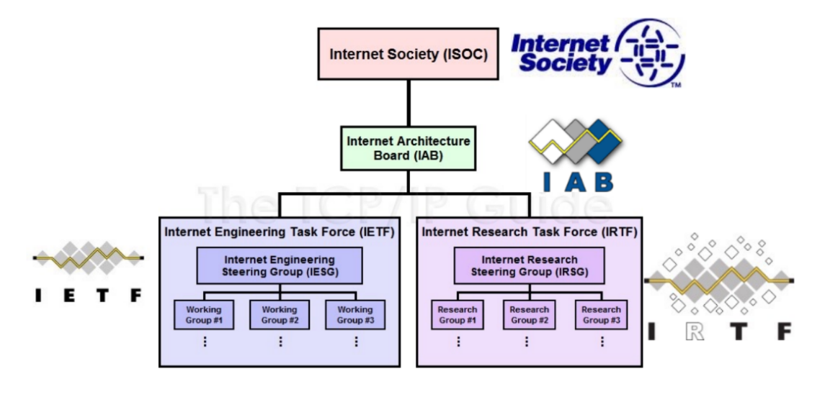

|  |  |
| --- | --- |
| IEEE  38 societies  130 journals  1,300 conferences each year  1,300 standards and projects  400,000 members  160 countries  IEEE 802.3  IEEE 802.11 |  |

(Materials, University Of Greenwich Learning, 2021)

1. **Explain the impact of network topology, communication and bandwidth requirements**
   * + 1. **Define topology**

Provides different configurations that are used to create a network.

Is a pattern of network devices and describes the way in which these devices are connected.

Topologies can be physical or logical.

Physical topology refers to the actual physical structure of the network, while a logical topology determines the way in which the data actually passes through the network from one device to other.

* + - 1. **Type of Topology:**
         1. **Bus Topology I:**

All devices are connected to a common cable called backbone/trunk

Operates in daisy chain fashion

Medium is shared that’s why creates collision

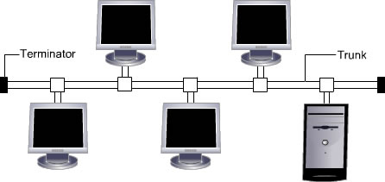

Server is at one end and devices are at different positions

50 ohm terminators are used

Devices are not responsible for data transmission

10BASE5

10BASE2

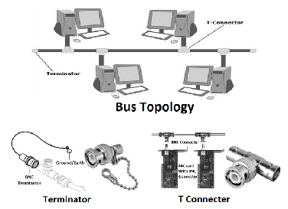

* 1. **Start Topology:**

**Introduction:**

Each device is connected to a central device called hub through cable.

Data passes through hub before reaching destination.

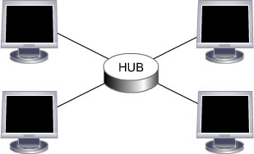

**Advantages:**Reliable and offers greater speed.

No collisions.

Handles large volume of traffic

**Disadvantages:**More cabling is required compared to bus topology.

One faulty device affects the entire network.

Addition of devices affect network.

* 1. **Ring Topology**

**Introduction:**

Devices are connected in a closed loop.

All devices have equal access to media.

Device waits for its turn to transmit.

Most common type is Token Ring network

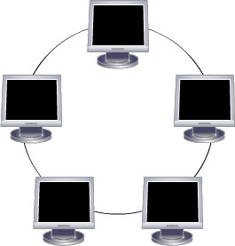

**Advantages:**Reliable and offers greater speed.

No collisions.

Handles large volume of traffic.

**Disadvantages:**More cabling is required compared to bus topology.

One faulty device affects the entire network.

Addition of devices affect network.

* 1. **Dual ring Topology:**

**Introduction:**

Consists of two independent primary and secondary ringsSecondary ring is redundant, used only when primary stops functioning

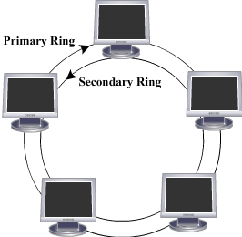

* 1. **Mesh Topology:**

**Introduction:**

Used in WANs to interconnect LANs.

Every device is connected to every other device.

Use routers to determine the best path of communication

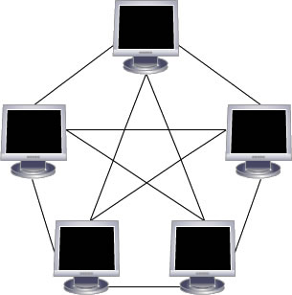

Full mesh topology – All devices are connected to each other.

Partial mesh topology - Some devices are connected to only those with whom they exchange most of the data

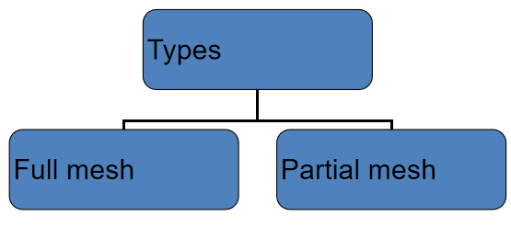

**Advantages:**Improves fault tolerance.

Failure of one link does not affect entire network.

Centralized management is not required.

**Disadvantages:**Difficult to install and manage.

Each link from one device to other requires individual NIC.

Expensive.

* 1. **Tree Topology:**

**Introduction:**

Combines the characteristic of linear bus and star topology.

Devices are wired to root hub.

Twisted pair cable is commonly used.

Lowest level devices are smaller computers

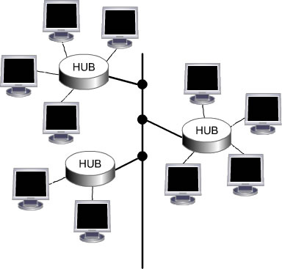

**Advantages:**Easy to expand the network.

Point-to-point wiring for each device.

Fault detection is easy.

**Disadvantages:**Difficult to configure.

If backbone breaks, entire network goes down.

More expensive

* 1. **Hybrid Topology:**

**Introduction:**

Hybrid topology is a network where two or more topologies are connected in such a way that the resulting network does not have one of the standard forms.

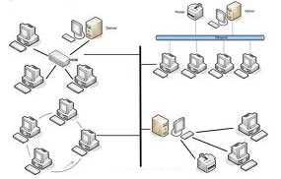

**Advantages:**Used for creating larger networks.

Handles large volume of traffic.

Fault detection is easy.

**Disadvantages:**Installation and configuration is difficult.

More expensive than other topologies.

More cabling is required

(Materials, University Of Greenwich Learning, 2021)

1. **Define network communication:**

Network communication, or internetworking, defines a set of protocols (that is, rules and standards) that allow application programs to talk with each other without regard to the hardware and operating systems where they are run. Internetworking allows application programs to communicate independently of their physical network connections.

The internetworking technology called TCP/IP is named after its two main protocols: Transmission Control Protocol (TCP) and Internet Protocol (IP). To understand TCP/IP, you should be familiar with the following terms:

**Client**

A process that requests services on the network.

**Server**

A process that responds to a request for service from a client.

**Datagram**

The basic unit of information, consisting of one or more data packets, which are passed across an Internet at the transport level.

**Packet**

The unit or block of a data transaction between a computer and its network. A packet usually contains a network header, at least one high-level protocol header, and data blocks. Generally, the format of data blocks does not affect how packets are handled. Packets are the exchange medium used at the Internetwork layer to send data through the network.

(Copyright IBM Corporation, 2015)

1. **Network rules.**
   * + - 1. **Rules in the network**

**Connectivity rules**

Connectivity rules define which features can be geometrically coincident or associated.

There are three types of connectivity rules:

Junction-junction connectivity rules govern the establishment of a connectivity association between two junction features that are not necessarily geometrically coincident. This rule type supports terminal connectivity. Junction-junction connectivity rules are created between datasets at the asset group and asset type levels—these rules build on top of existing feature restrictions for valid connectivity associations. These rules are evaluated when an association is created. If there is no rule to support the association, an error is returned and the feature is not added to the Modify Associations pane.

Junction-edge connectivity rules govern the types of junction features that can be connected to edge features. These rules build on top of existing feature restrictions for valid geometric coincidence and connectivity associations. Junction-edge rules are evaluated when you enable or validate the network topology.

Edge-junction-edge connectivity rules are based on geometric coincidence or connectivity associations. These control the types of line features or edge objects that can be connected using an intermediate junction feature or junction object. Edge-junction-edge connectivity rules are evaluated when you enable or validate the network topology.

**Structural attachment rules**

Structural attachment rules constrain the types of features that can be attached to a given type of feature

(structure). This rule type does not support terminal connectivity. Structural attachment rules are created between structure features and attachment features. Attachment features can be from the device, junction, assembly, and structure junction feature classes, as well as junction and structure junction object tables. These rules are established at the asset group and asset type levels and build on existing feature restrictions for valid structural attachment associations.

**Containment rules**

Containment rules constrain the types of features that can be contained in a given type of feature (container). This rule type does not support terminal connectivity. Containment rules are created between datasets at the asset group and asset type levels—these rules build on top of existing feature restrictions for valid containment associations

* + - * 1. **Why network rules are needed?**

Rules are an important component of data quality. When used in conjunction, network rules and attribute rules help maintain data integrity.

Network rules dictate which network features can connect or associate in the utility network. These rules are imposed at the class level for specific asset groups and asset types. Features and objects can connect and associate as long as feature restrictions are respected and network rules exist to allow such relationships.

(ArcGIS Pro, 2021)

1. **Bandwidth.**

**Define bandwidth.**

Network bandwidth is a measurement indicating the maximum capacity of a wired or wireless communications link to transmit data over a network connection in a given amount of time. Typically, bandwidth is represented in the number of bits, kilobits, megabits or gigabits that can be transmitted in 1 second. Synonymous with capacity, bandwidth describes data transfer rate. Bandwidth is not a measure of network speed -- a common misconception.

**Why bandwidth requirement is needed for networks?**

Bandwidth is not an unlimited resource. In any given deployment location, such as a home or business, there is only so much capacity available. Sometimes, this is due to physical limitations of the network device, such as the router or modem, cabling or wireless frequencies being used. Other times, bandwidth is intentionally rate-limited by a network administrator or internet or wide area network (WAN) carrier.

Multiple devices using the same connection must share bandwidth. Some devices, such as TVs that stream 4K video, are bandwidth hogs. In comparison, a webinar typically uses far less bandwidth. Although speed and bandwidth are not interchangeable, greater bandwidth is essential to maintain tolerable speeds on multiple devices. To help illustrate this, here's the average bandwidth consumed for various services:

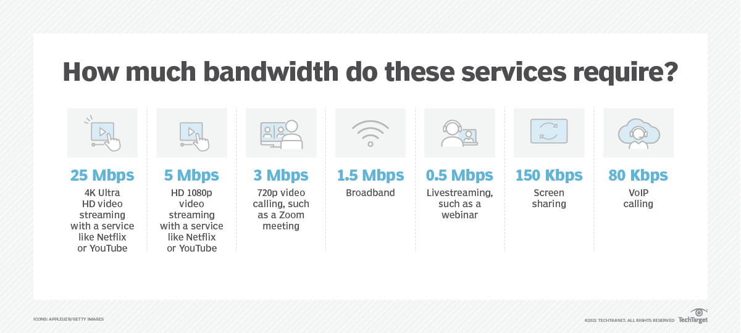

(Andrew Froehlich, 2021)

# Discuss the operating principles of networking devices and server types.

## Discuss how switches and routers operate in a network.

### How switch operate in a network.

When switch receives data from one of the connected devices, it forwards data only to the port on which the destination system is connected.

Uses the Media Access Control (MAC) address of the devices to determine the correct port.

Refers to MAC table which stores MAC address with corresponding port number.

### How router operate in a network.

Operate at Network Layer of the OSI model

Can connect nearer or far network segments

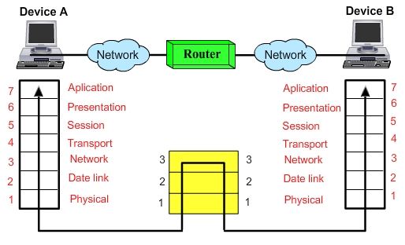

Works in LAN, MAN and WAN environments

Having LAN and WAN ports

WAN port connects to regular phone line or more advanced telephone connection like ISDN, ADSL, T1 or may be a cable modem

Route the packets seeing the IP address stored in the packet

Comes in variety shapes, sizes and functions

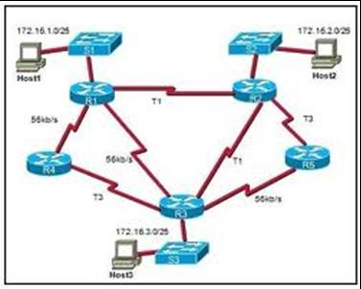

## 2. List some other common networking devices specify their uses, and under what circumstances.

* + - * 1. **Network Interface Card (NIC)**

In a network, to send the data the node requires the destination address.

In a network, each node should have its own address to send and receive their data.

This address is known as physical or MAC (Media Access Control) address.

It is provided by a device known as Network Interface Card (NIC) and it operates at layer 2 of the OSI model.

A Network Interface Card (NIC) is a hardware device that is used to connect a node onto a network.

NIC is fitted into the expansion slot inside the computer. It serves as a link for sending and receiving data on the network.

It can support a transfer rate of 10, 100 or 1000 Mbit/s. The user can select an NIC depending on the type of network, protocol and media.

* + - * 1. **Hub**

Simplest and low cost device

Also known as Multi-port Repeater

Operates at Physical Layer like Repeater

Transfers data to all the ports

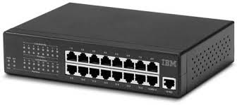

* 1. **Operation of Hub**

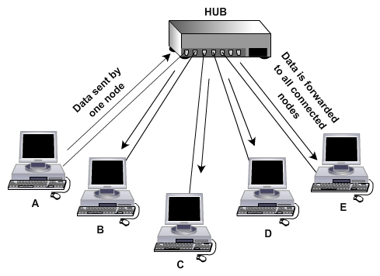

* 1. **Ethernet Card**

Ethernet cards are of two types:

-Wired

-Wireless

Different types of Wired Ethernet cards can be used depending on the type of network and corresponding connector that is required. The different types of Wired Ethernet cards are:

-1000BaseT NIC

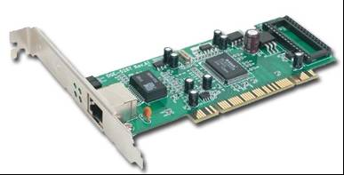

-Fiber – optic NIC

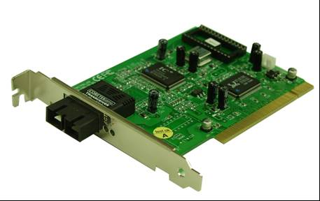

* 1. **Bridge**

A device that can forward information and is supported by a physical address is called a Bridge. In technical terms, packets are filtered and forwarded by physical address through a Bridge.

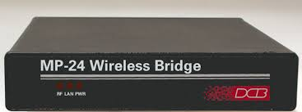

* 1. **Gateway**

Is a networking device which acts as an entrance (or a gate) for another network.

In enterprises, the gateway is the computer that routes the traffic from an internal network to the outside network.

The gateway node often acts as a proxy server or a firewall or a router.

A default gateway is the one that meets the following criteria:

-It is on the same subnet as your computer.

-It is the gateway that your computer depends upon when it does not know through which route to send the traffic towards destination.

Gateway works at all levels of the OSI model

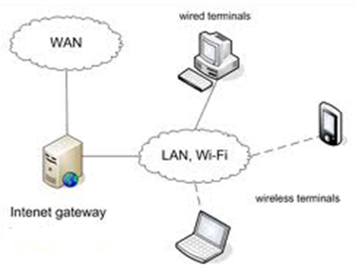

The gateway has two sides, WAN side and LAN side.

The WAN side connects to modem and therefore to the Internet via ISP and the LAN side connects to the network via hub or switch. So, while configuring gateway you need to configure both WAN and LAN sides.

Firewall is a gateway device.

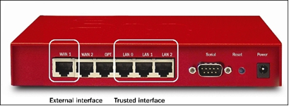

(Materials, University Of Greenwich Learning, 2021)

## 3. Some common types of servers

* + - * 1. **Web server**

An open-source web server is used for accessing the world wide web through public domain software. These servers connect stored information from an internet website to your own computer. Web servers store information for the internet that is retrieved via "HTTP" code and sent to your web browser. This is one of the most widely used types of servers.

* + - * 1. **Proxy server**

Proxy servers act as a bridge between a host server and a client server. A proxy sends data from a website to your computer IP address after it passes through the proxy's server. This practice adds a layer of security since the information is requested then transferred from the source to the proxy server and never directly from a client to another user. A proxy server can filter out various harmful internet entities.

* + - * 1. **Virtual machine (VM)**

As their name suggests, virtual machines store and connect data strictly through virtual space. To create a virtual machine, IT teams use a hypervisor, also known as a virtual machine monitor (VMM), which is software that can run thousands of virtual machines through only one piece of physical hardware. This method of server virtualization is widely used for data transfer and storage because they are the most cost-effective type of server to run.

* + - * 1. **File transfer protocol (FTP) server**

FTP servers are used to relocate files from one computer to another. Uploaded files move from your computer to the server while downloaded files are extracted from the server onto your device. File transfer protocol also refers to the method of using a server to connect one computer to another in order to share data safely.

* + - * 1. **Application server**

These servers connect clients to software applications through virtual server connections. This allows users to bypass downloading data to their own hardware in order to access applications. Application servers can effectively host large amounts of application data to many users at once, making them ideal for businesses.

* + - * 1. **File server**

A file server stores data files for multiple users. They allow for faster data retrieval and saving or writing files to a computer. This is a basic type of server used commonly by organizations where lots of users need access to files that are more conveniently and safely stored on a server than a personal computer.

* 1. **Database server**

Database servers function as large storage spaces that organizations use and access to run multiple programs to meet their needs. A database server can run independently of any database architecture.

* 1. **Print server**

A print server connects remotely to local computers to print through a network. These servers give businesses the ability to use a single printer to serve an entire department. Some printers even come with their own built-in server ready to join a network once they're installed in an office area.

* 1. **Domain name system (DNS) server**

These servers transform readable computer domain names into computer language IP addresses. The DNS server takes search data from a user and finds the requested address to deliver to the client device.

* 1. **Collaboration server**

When work needs to be shared across multiple users, a collaboration server makes it easy to connect. These servers allow you to share and store files, applications and other large amounts of data.

* 1. **Gaming server**

Large gaming networks use servers to connect users from around the world. These servers host multi-player online games.

* 1. **Monitoring and management server**

Monitoring and management servers function in several capacities. First, they record and track digital transactions and receive user requests. Others simply monitor and don't actively participate in user operations. Monitoring servers are responsive to network administrators who survey network health to check for threats or bugs in the system.

(Indeed, 2021)

# Discuss the inter-dependence of workstation hardware with relevant networking software.

## Definition of workstation hardware:

A workstation (WS) is a computer dedicated to a user or group of users engaged in business or professional work. It includes one or more high resolution displays and a faster processor than a personal computer (PC). A workstation also has greater multitasking capability because of additional random access memory (RAM), drives and drive capacity. A workstation may also have a higher-speed graphics adapters and more connected peripherals.

The term workstation also has been used to reference a PC or mainframe terminal on a local area network (LAN). These workstations may share network resources with one or more large client computers and network servers.

(Techopedia, 2012)

## Definition of networking software:

Network software is an extremely broad term for a range of software aimed at the design and implementation of modern networks. Various types of network software support the creation, calibration and operation of networks.

(Techopedia)

* + - 1. **Definition of inter**-**dependencies:**

Hardware and software” are inter-dependent on each other. To produce useful result hardware and software should work together in the computer system. Software programs are required to operate and get results from the computer hardware. The computer system cannot be utilized and useless without it.

(Brainly.in)

* + - 1. **The inter-dependence of workstation hardware with relevant networking software:**

Both hardware and software are necessary for the proper functioning of the computer. The software cannot be utilized without hardware while the hardware cannot be utilized without software. The difference between hardware and software is that hardware refers to physical components of a computer while software refers to a set of instructions given to a computer to perform a certain task.

(Brainly.in)

# References

Andrew Froehlich, 2021. *www.techtarget.com.* [Online]   
Available at: https://www.techtarget.com/searchnetworking/definition/bandwidth  
[Accessed 2021].

ArcGIS Pro, 2021. *pro.arcgis.com.* [Online]   
Available at: https://pro.arcgis.com/en/pro-app/2.6/help/data/utility-network/network-rules.htm

Brainly.in, n.d. *brainly.in.* [Online]   
Available at: https://brainly.in/question/13116085  
[Accessed 2021].

Brainly.in, n.d. *Brainly.in.* [Online]   
Available at: https://brainly.in/question/11500260  
[Accessed 2021].

Cloudflare, 2021. *cloudflare.com.* [Online]   
Available at: https://www.cloudflare.com/learning/network-layer/what-is-a-protocol/  
[Accessed 2021].

College of Education, University of South Florida, 1997-2013. [Online]   
Available at: https://fcit.usf.edu/network/chap1/chap1.htm  
[Accessed 2021].

Copyright IBM Corporation, 2015. *IBM.com.* [Online]   
[Accessed 2021].

Indeed, 2021. *Indeed.com.* [Online]   
Available at: https://www.indeed.com/career-advice/career-development/types-of-servers  
[Accessed 2021].

Materials, University Of Greenwich Learning, 2021. [Online]   
Available at: https://flm.greenwich.edu.vn/DefaultSignin?msg=Thread%20was%20being%20aborted.

Stéphane Bourgeois, 2016. *www.belden.com.* [Online]   
Available at: https://www.belden.com/blogs/network-types  
[Accessed 2021].

Techopedia, 2012. *www.techopedia.com.* [Online]   
Available at: https://www.techopedia.com/definition/5140/workstation-ws  
[Accessed 2021].

Techopedia, n.d. *www.techopedia.com.* [Online]   
Available at: https://www.techopedia.com/definition/4317/network-software  
[Accessed 2021].